MD5 Collision Attack Lab

NAME: JASHWANTH REDDY GANGULA

SUID: 646254141

1 Introduction

A secure one-way hash function must satisfy two properties

i)one-way property: Given a hash value h, it should be computationally infeasible to find an input M such that hash(M) = h  
ii)Collision-resistance property: It should be computationally infeasible to find two inputs M1 and M2 such that  
hash(M1) = hash(M2)  
In this lab, we will look into why collision-resistance property is important, and what damages can be caused if a widely used one-way function’s collision-resistance is broken. We will try to launch actual collision attacks against MD5 hash function. We will demonstrate two different programs that share the same MD5 hash but have different behaviors.

Lab Environment:   
We will use a binary called md5collgen , which is a “Fast MD5 Collision Generation” tool.

2 Lab Tasks  
2.1 Task 1: Generating Two Different Files with the Same MD5 Hash. The prefix for these two files needs to be the same. The command is “md5collgen prefix.txt –o out1.bin out2.bin”. Please observe that md5sum on out1.bin and out2.bin is the same.  
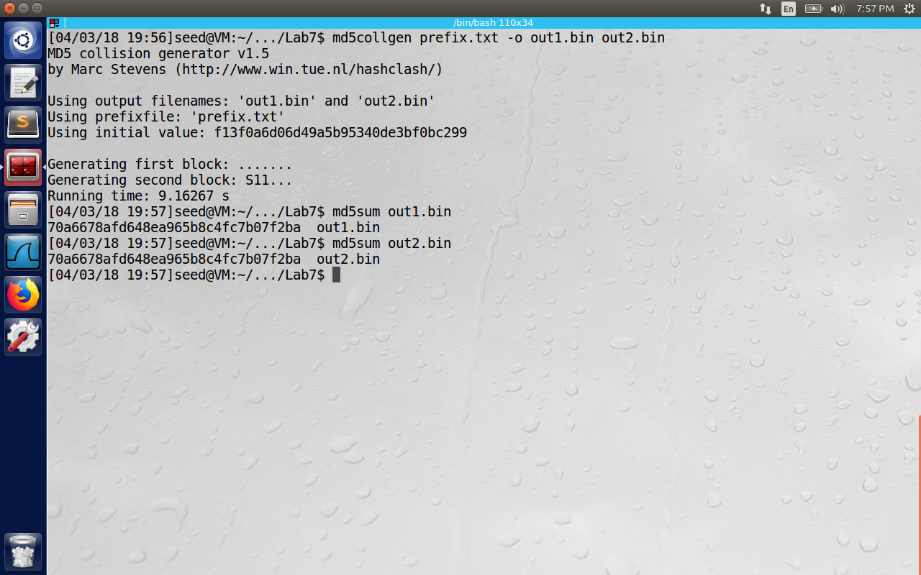

Please observe in the image below. We have opened both the files out1.bin and out2.bin, the prefix is the same for both of them highlighted in text below.

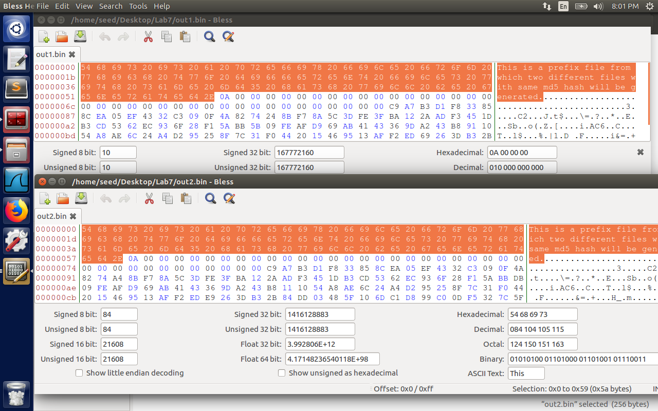

Question 1. If the length of your prefix file is not multiple of 64, what is going to happen?  
The message is padded with bits so that its length is congruent to modulo 512.  
(len = 448 mod 512). A single 1 bit is appended then followed by 0 bits. Now a 64-bit binary is appended to the result of previous step, making it a total of 512 bits.

Question 2. Create a prefix file with exactly 64 bytes, and run the collision tool again, and see what happens.

In the first command the length of prefix_64.txt is 64 bytes. The length of out1_64.bin and out2_64.bin is 192 bytes(highlighted in black)  
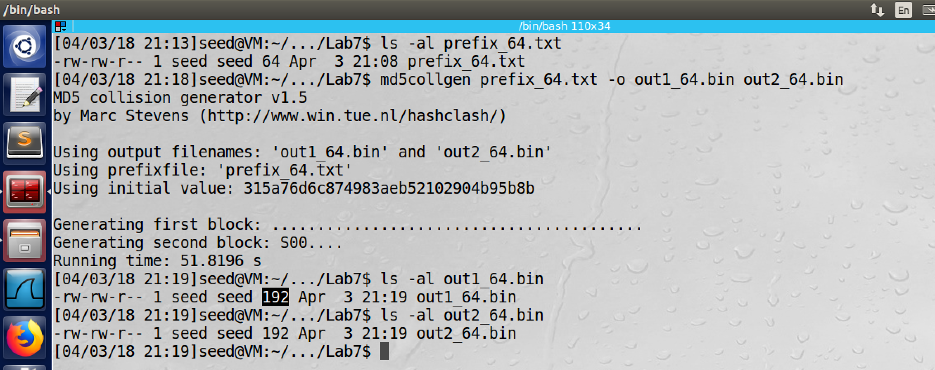

Question 3. Are the data (128 bytes) generated by md5collgen completely different for the two output files? Please identify all the bytes that are different.  
Only some bytes were found to be different. One such byte is highlighted.(1B-9B in the same highlighted line, EA-6A in the last but one line)  
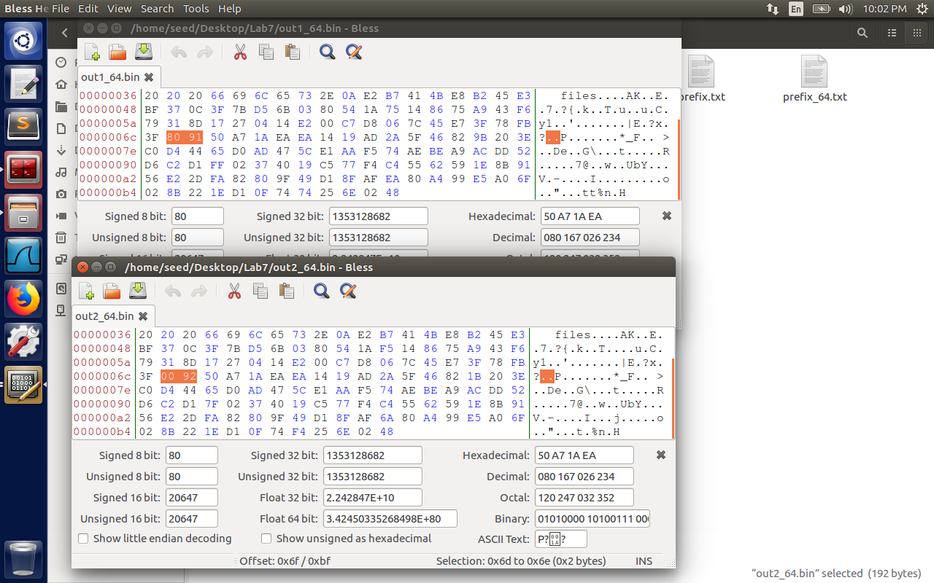

2.2 Task 2: Understanding MD5’s Property

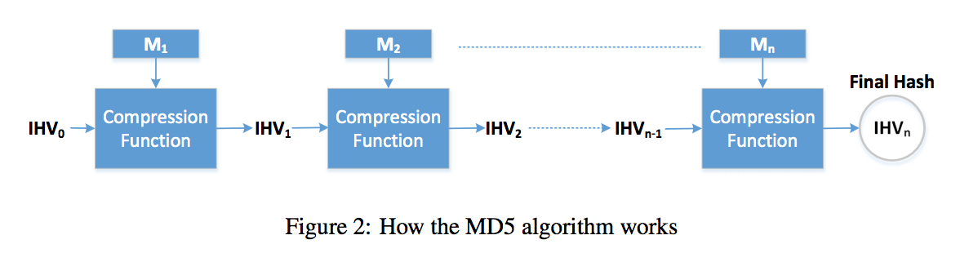

Here the input is divided into block of 64 bytes, and then compute the hash iteratively on these blocks. The compression function takes a 128-bit intermediate hash value and is fed into next iteration. The last iteration produces the final hash value. Now we can derive the following property. If MD5(M) = MD5(N) then MD5(M || T) = MD5(N || T), where || represents the concatenation.

2.3 Task 3: Generating Two Executable Files with the Same MD5 Hash

In this task, we have a C program where we need to create two different versions of this program such that contents of arrays are different, but the hash value remains the same.

The program is as below.

#include<stdio.h>

/* The actual contents of this array are up to you */

unsigned char xyz[200] =

{0x41, 0x41, 0x41, 0x41, 0x41, 0x41, 0x41, 0x41, 0x41, 0x41,

0x41, 0x41, 0x41, 0x41, 0x41, 0x41, 0x41, 0x41, 0x41, 0x41,

0x41, 0x41, 0x41, 0x41, 0x41, 0x41, 0x41, 0x41, 0x41, 0x41,

0x41, 0x41, 0x41, 0x41, 0x41, 0x41, 0x41, 0x41, 0x41, 0x41,

0x41, 0x41, 0x41, 0x41, 0x41, 0x41, 0x41, 0x41, 0x41, 0x41,

0x41, 0x41, 0x41, 0x41, 0x41, 0x41, 0x41, 0x41, 0x41, 0x41,

0x41, 0x41, 0x41, 0x41, 0x41, 0x41, 0x41, 0x41, 0x41, 0x41,

0x41, 0x41, 0x41, 0x41, 0x41, 0x41, 0x41, 0x41, 0x41, 0x41,

0x41, 0x41, 0x41, 0x41, 0x41, 0x41, 0x41, 0x41, 0x41, 0x41,

0x41, 0x41, 0x41, 0x41, 0x41, 0x41, 0x41, 0x41, 0x41, 0x41,

0x41, 0x41, 0x41, 0x41, 0x41, 0x41, 0x41, 0x41, 0x41, 0x41,

0x41, 0x41, 0x41, 0x41, 0x41, 0x41, 0x41, 0x41, 0x41, 0x41,

0x41, 0x41, 0x41, 0x41, 0x41, 0x41, 0x41, 0x41, 0x41, 0x41,

0x41, 0x41, 0x41, 0x41, 0x41, 0x41, 0x41, 0x41, 0x41, 0x41,

0x41, 0x41, 0x41, 0x41, 0x41, 0x41, 0x41, 0x41, 0x41, 0x41,

0x41, 0x41, 0x41, 0x41, 0x41, 0x41, 0x41, 0x41, 0x41, 0x41,

0x41, 0x41, 0x41, 0x41, 0x41, 0x41, 0x41, 0x41, 0x41, 0x41,

0x41, 0x41, 0x41, 0x41, 0x41, 0x41, 0x41, 0x41, 0x41, 0x41,

0x41, 0x41, 0x41, 0x41, 0x41, 0x41, 0x41, 0x41, 0x41, 0x41,

0x41, 0x41, 0x41, 0x41, 0x41, 0x41, 0x41, 0x41, 0x41, 0x41};

int main()

{

int i;

for (i=0; i<200; i++) {

printf("%x", xyz[i]);

}

printf("\n");

}

We break the executable into three pieces. The prefix is multiple of 64 bytes. The suffix is the rest of the program, but we put P and Q generated from md5collgen command as 128 bytes. Since md5 is iterative hashing algorithm, even though the md5sum of two programs are same, the output generated will be different.

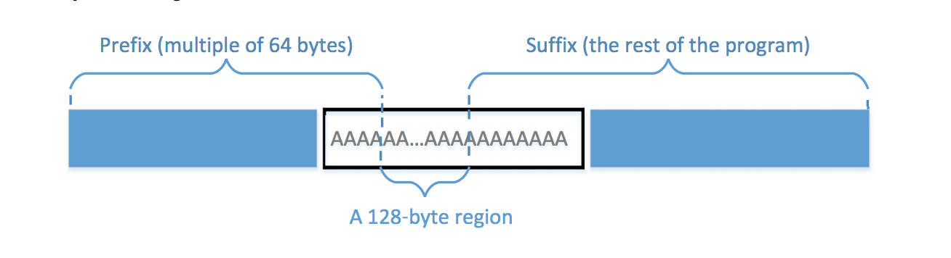

The task3 executable is opened using bless editor. The range of address of prefix is 0000->0000103F. Hence prefix length = 4160 bytes. (4160 / 64 = 65) .

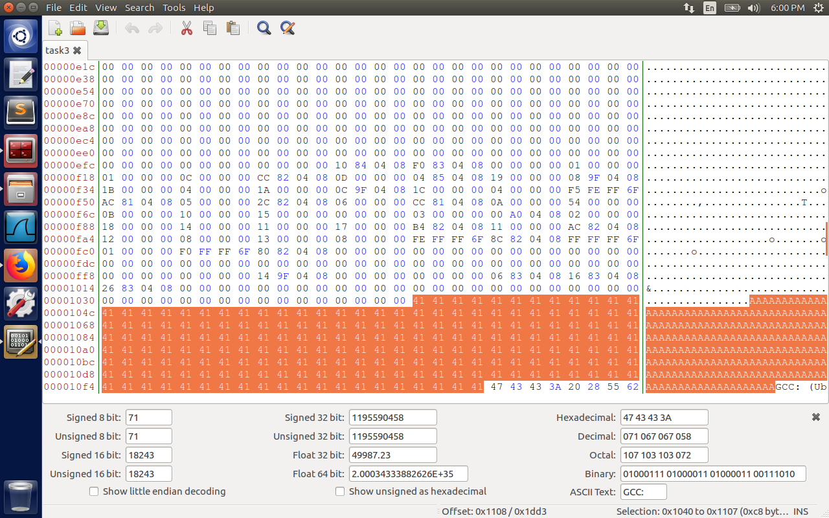

Now we apply md5collgen to generate different files for the same prefix.The files are task3_out1.bin and task3_out2.bin.  
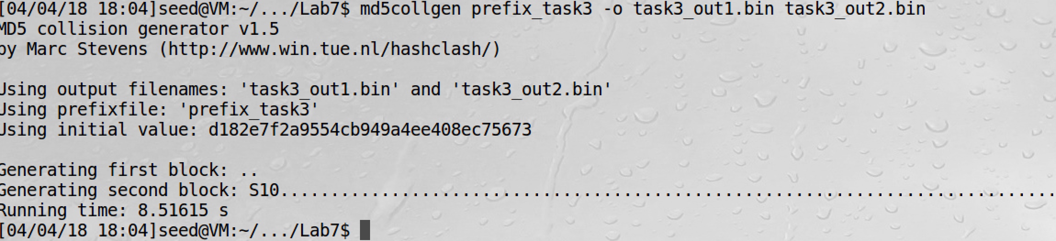

The task3_out1.bin is opened in bless hexadecimal editor. The highlighted text is 128 bytes starting from address 1040 to 10bc = 0x80 = 128 bytes.

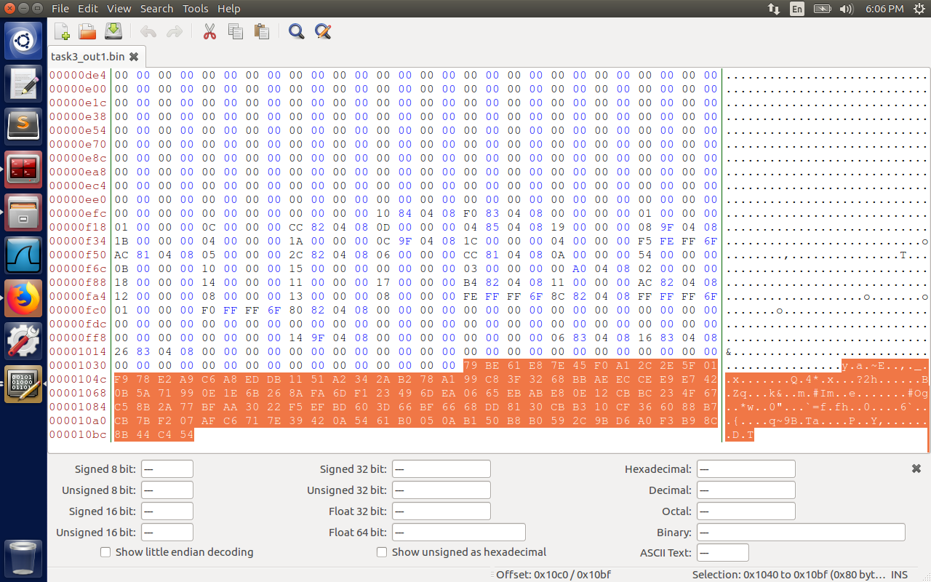

The task3_out2.bin is opened in bless hexadecimal editor. The highlighted text is 128 bytes starting from address 1040 to 10bf = 0x80 = 128 bytes.  


Please observe that md5sum of task3_out1.bin and task3_out2.bin are the same.  
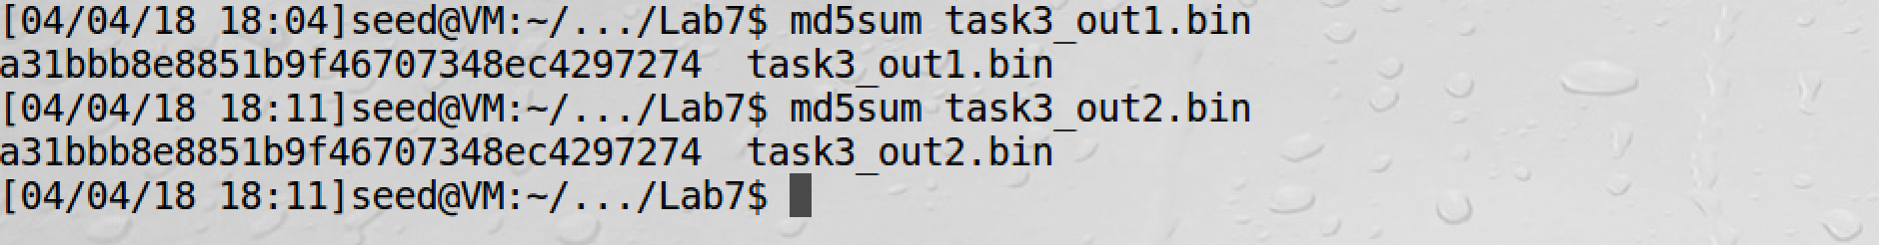

Now we create two binary files , which are initially same copy as of task3 executable.  
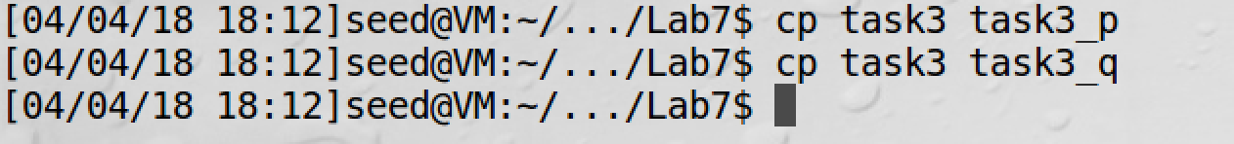

We open task3_p in bless editor, and change the 128 bytes after the prefix to last 128 bytes of task3_out1.bin .

Before modification of task3_p executable, the value is 0x41 (from address 1040 to 10bf = 128 bytes).   
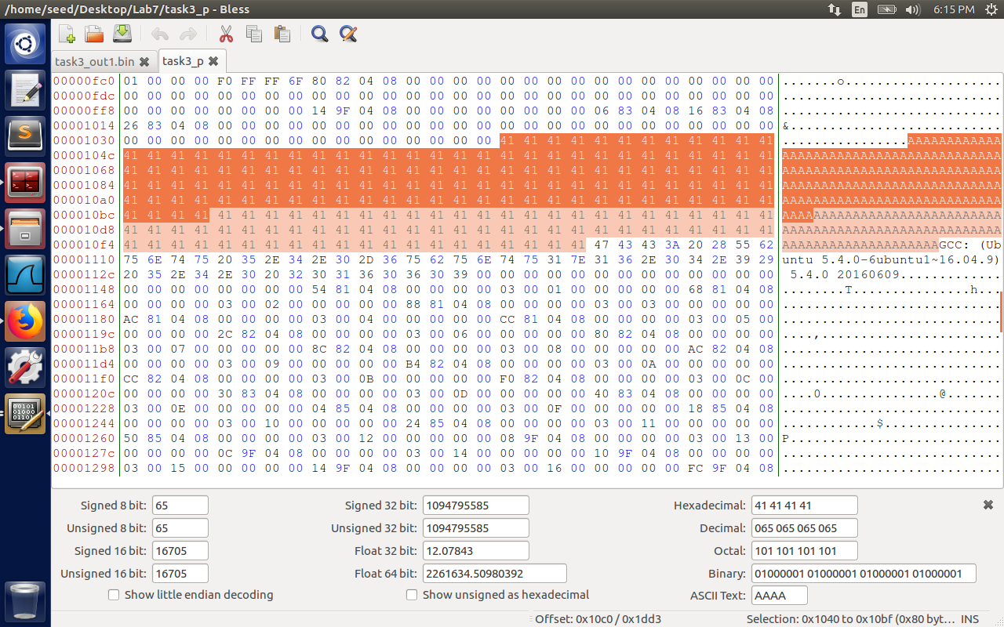

After modification:  
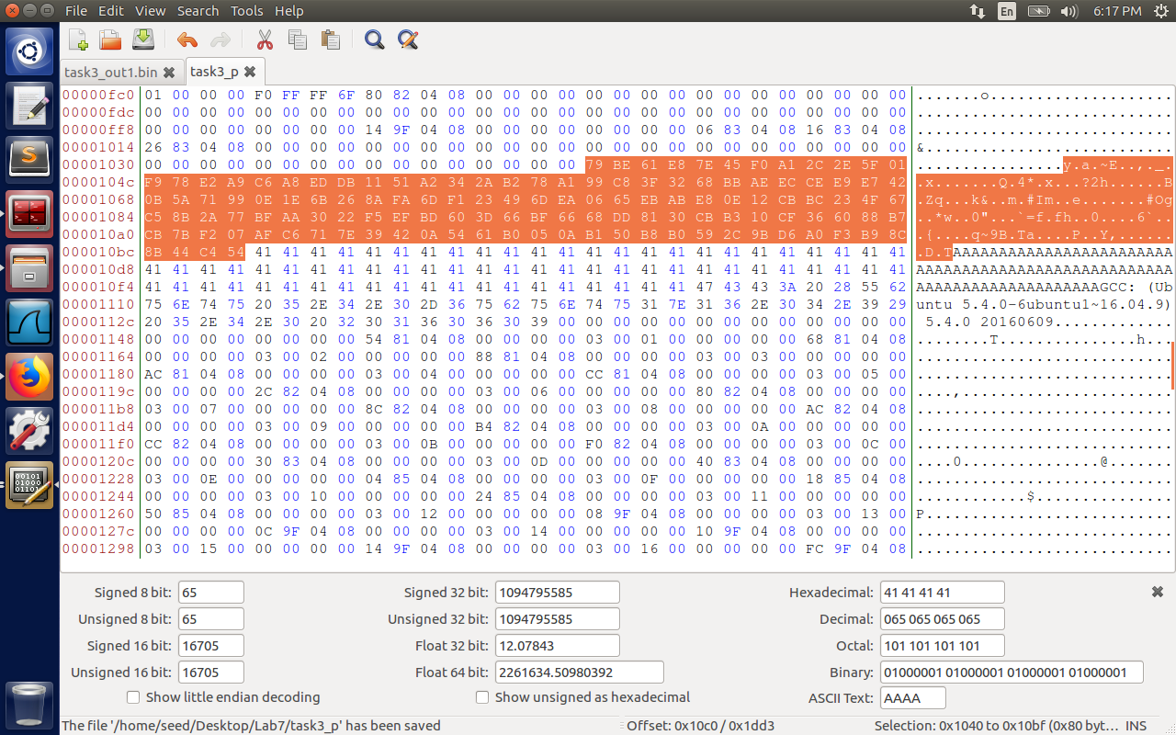

We repeat the same process for task3_q executable.  
Before modification:  
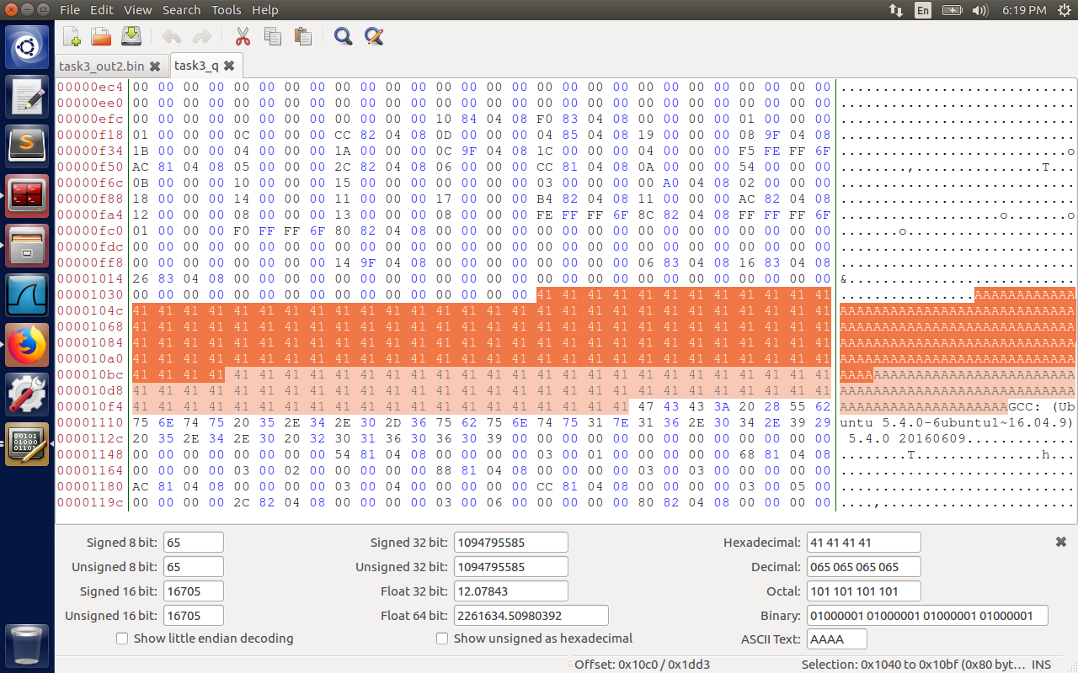

After modification:  


Now the outputs of task3_p and task3_q are different. (Please observe the end of second lines of both 61b05ab1 vs 61305ab1…), but the md5sum is the same for different executables.

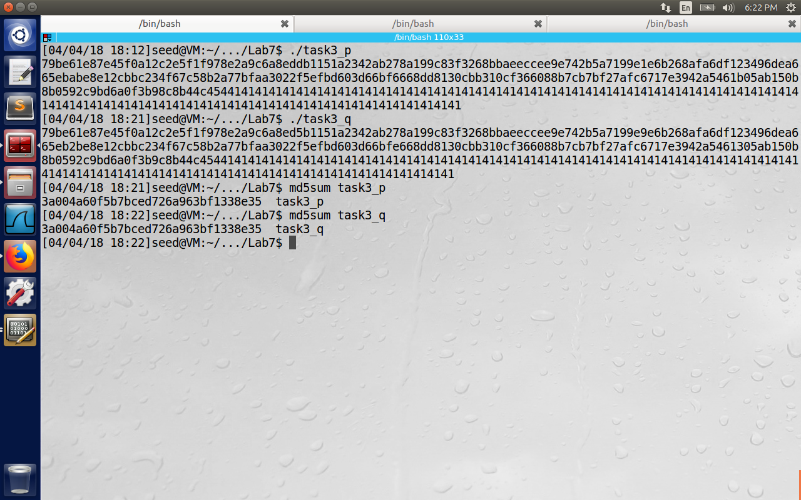

2.4 Task 4: Making the Two Programs Behave Differently

2.4 Task 4: Making the Two Programs Behave Differently

In the previous task, two program differ only in their data, but in this task, we will modify the behavior. One program executes the benign instructions while the other program executes the malicious instructions. Both of them should produce the same md5 value. We can send the benign program to the trusted authority for verification, but we can let the users download the malicious program that is trusted by them because both of them will have identical md5 signature. The original program is as below.

#include<stdio.h>

/* The actual contents of this array are up to you */

unsigned char x[200] =

{0x41, 0x41, 0x41, 0x41, 0x41, 0x41, 0x41, 0x41, 0x41, 0x41,

0x41, 0x41, 0x41, 0x41, 0x41, 0x41, 0x41, 0x41, 0x41, 0x41,

0x41, 0x41, 0x41, 0x41, 0x41, 0x41, 0x41, 0x41, 0x41, 0x41,

0x41, 0x41, 0x41, 0x41, 0x41, 0x41, 0x41, 0x41, 0x41, 0x41,

0x41, 0x41, 0x41, 0x41, 0x41, 0x41, 0x41, 0x41, 0x41, 0x41,

0x41, 0x41, 0x41, 0x41, 0x41, 0x41, 0x41, 0x41, 0x41, 0x41,

0x41, 0x41, 0x41, 0x41, 0x41, 0x41, 0x41, 0x41, 0x41, 0x41,

0x41, 0x41, 0x41, 0x41, 0x41, 0x41, 0x41, 0x41, 0x41, 0x41,

0x41, 0x41, 0x41, 0x41, 0x41, 0x41, 0x41, 0x41, 0x41, 0x41,

0x41, 0x41, 0x41, 0x41, 0x41, 0x41, 0x41, 0x41, 0x41, 0x41,

0x41, 0x41, 0x41, 0x41, 0x41, 0x41, 0x41, 0x41, 0x41, 0x41,

0x41, 0x41, 0x41, 0x41, 0x41, 0x41, 0x41, 0x41, 0x41, 0x41,

0x41, 0x41, 0x41, 0x41, 0x41, 0x41, 0x41, 0x41, 0x41, 0x41,

0x41, 0x41, 0x41, 0x41, 0x41, 0x41, 0x41, 0x41, 0x41, 0x41,

0x41, 0x41, 0x41, 0x41, 0x41, 0x41, 0x41, 0x41, 0x41, 0x41,

0x41, 0x41, 0x41, 0x41, 0x41, 0x41, 0x41, 0x41, 0x41, 0x41,

0x41, 0x41, 0x41, 0x41, 0x41, 0x41, 0x41, 0x41, 0x41, 0x41,

0x41, 0x41, 0x41, 0x41, 0x41, 0x41, 0x41, 0x41, 0x41, 0x41,

0x41, 0x41, 0x41, 0x41, 0x41, 0x41, 0x41, 0x41, 0x41, 0x41,

0x41, 0x41, 0x41, 0x41, 0x41, 0x41, 0x41, 0x41, 0x41, 0x41};

unsigned char y[200] =

{0x41, 0x41, 0x41, 0x41, 0x41, 0x41, 0x41, 0x41, 0x41, 0x41,

0x41, 0x41, 0x41, 0x41, 0x41, 0x41, 0x41, 0x41, 0x41, 0x41,

0x41, 0x41, 0x41, 0x41, 0x41, 0x41, 0x41, 0x41, 0x41, 0x41,

0x41, 0x41, 0x41, 0x41, 0x41, 0x41, 0x41, 0x41, 0x41, 0x41,

0x41, 0x41, 0x41, 0x41, 0x41, 0x41, 0x41, 0x41, 0x41, 0x41,

0x41, 0x41, 0x41, 0x41, 0x41, 0x41, 0x41, 0x41, 0x41, 0x41,

0x41, 0x41, 0x41, 0x41, 0x41, 0x41, 0x41, 0x41, 0x41, 0x41,

0x41, 0x41, 0x41, 0x41, 0x41, 0x41, 0x41, 0x41, 0x41, 0x41,

0x41, 0x41, 0x41, 0x41, 0x41, 0x41, 0x41, 0x41, 0x41, 0x41,

0x41, 0x41, 0x41, 0x41, 0x41, 0x41, 0x41, 0x41, 0x41, 0x41,

0x41, 0x41, 0x41, 0x41, 0x41, 0x41, 0x41, 0x41, 0x41, 0x41,

0x41, 0x41, 0x41, 0x41, 0x41, 0x41, 0x41, 0x41, 0x41, 0x41,

0x41, 0x41, 0x41, 0x41, 0x41, 0x41, 0x41, 0x41, 0x41, 0x41,

0x41, 0x41, 0x41, 0x41, 0x41, 0x41, 0x41, 0x41, 0x41, 0x41,

0x41, 0x41, 0x41, 0x41, 0x41, 0x41, 0x41, 0x41, 0x41, 0x41,

0x41, 0x41, 0x41, 0x41, 0x41, 0x41, 0x41, 0x41, 0x41, 0x41,

0x41, 0x41, 0x41, 0x41, 0x41, 0x41, 0x41, 0x41, 0x41, 0x41,

0x41, 0x41, 0x41, 0x41, 0x41, 0x41, 0x41, 0x41, 0x41, 0x41,

0x41, 0x41, 0x41, 0x41, 0x41, 0x41, 0x41, 0x41, 0x41, 0x41,

0x41, 0x41, 0x41, 0x41, 0x41, 0x41, 0x41, 0x41, 0x41, 0x41};

int compare() {

for(int i = 0; i < 200;i++) {

if (x[i] == y[i]) {

continue;

} else {

return 1;

}

}

return 0;

}

int main()

{

int i;

if (compare() == 0) {

printf("Benign code executed..\n");

} else {

printf("Malicious code executed..\n");

}

printf("\n");

}

In the image below, we have two versions of the programs. In the first version the contents of X and Y are the same, (prefix followed by x followed by y

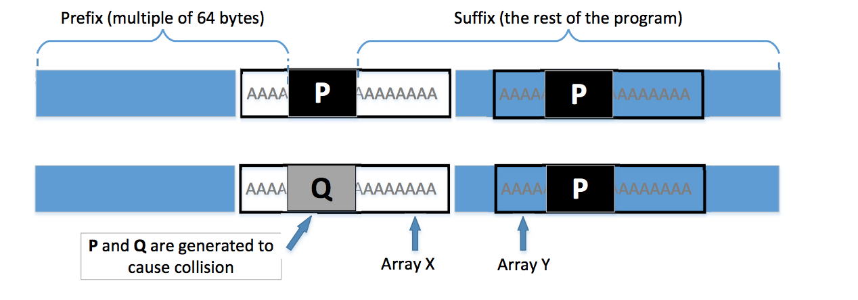

First we create prefix_task4 for the first 103f bytes of the task4 executable as shown below.  
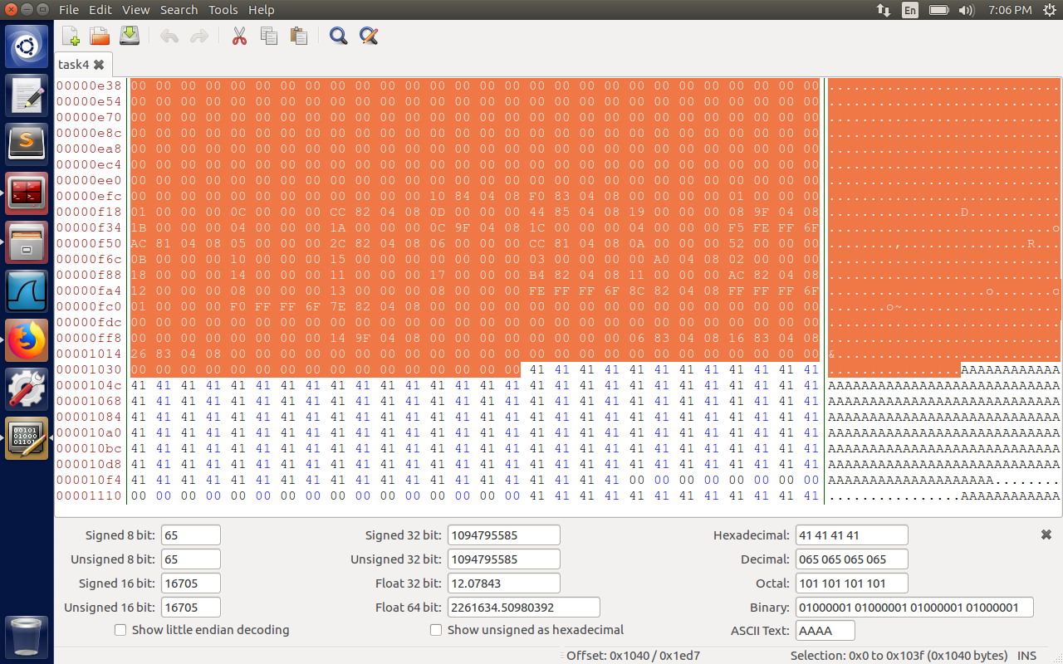

The highlighted text is copied to a new file, let’s call it prefix_task4. Now we will run md5collgen on prefix_task4 to generate two files task4_out1.bin and task4_out2.bin which have the same prefix and the same md5sum but different content apart from prefix. (call them p and q)

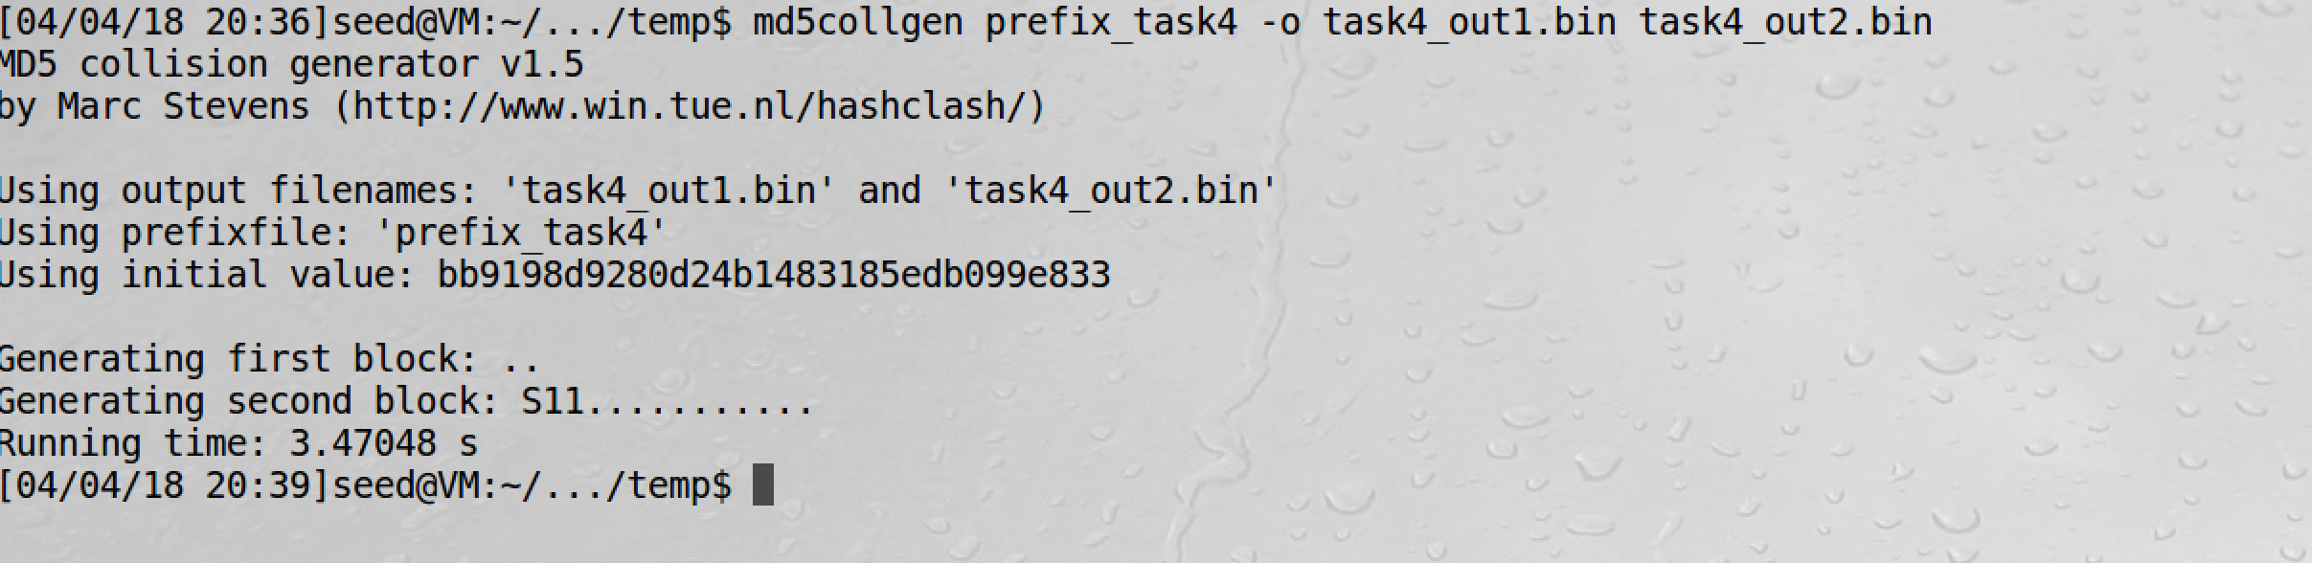

Here we have same prefix for task4_out1.bin and task4_out2.bin. The only difference is the last 128 bytes from address 1040 to 10bf = 0x80 = 128 bytes. (Please observe last but one line NIBK… vs UNIBK.. difference). We consider p to be from task4_out1.bin and q to be from task4_out2.bin.

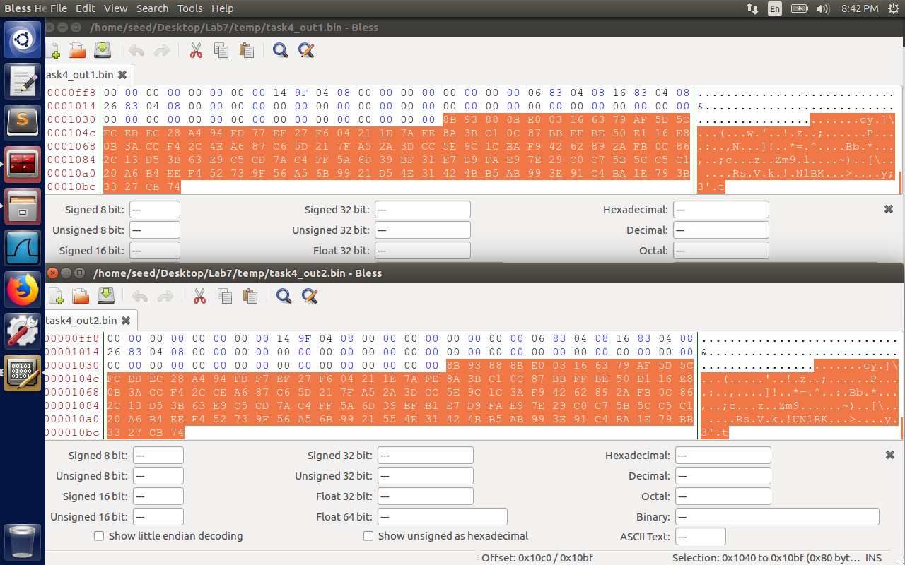

Before Modification of task4_good:  
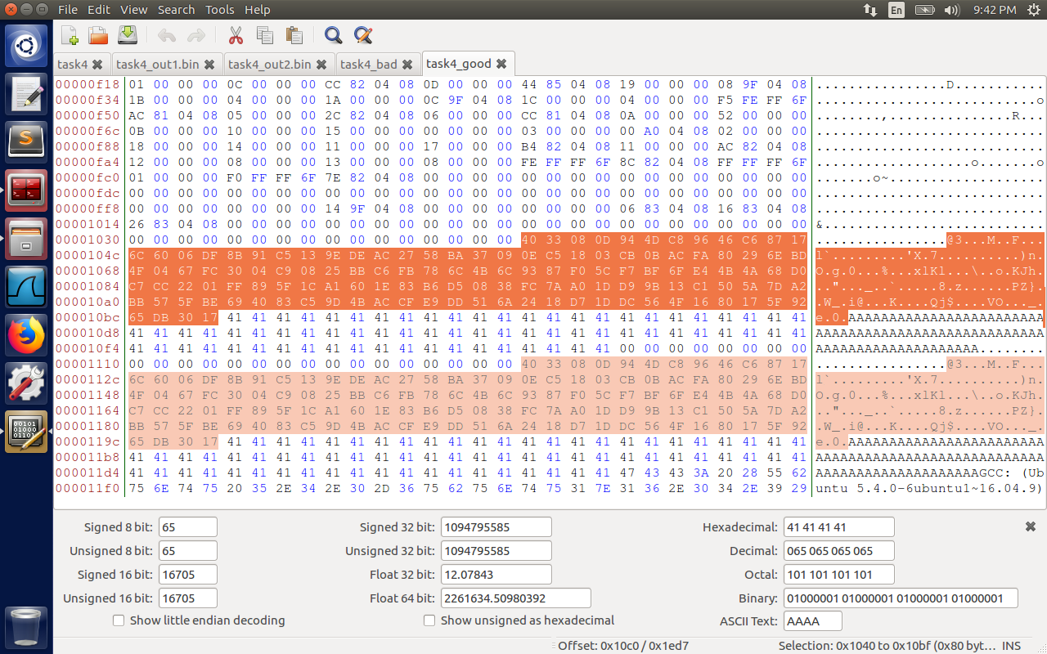

Now we modify the highlighted content with the content of p from task4_out1.bin.  
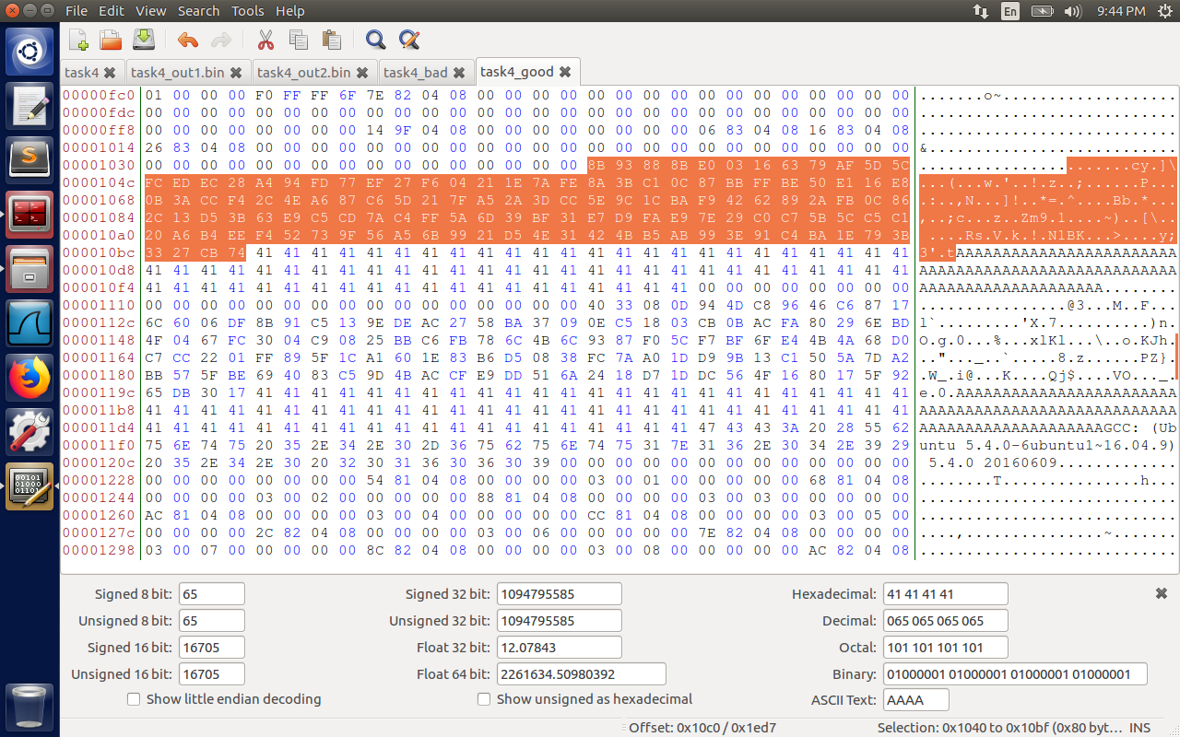

Since we are modifying the content of array x, we also have to modify the array Y, so that contents are equal and benign code is executed.

After Modifying the content of Y to P, so that arrays when compared are equal. Now observe both the contents are same(one is highlighted in dark, other in light color).  
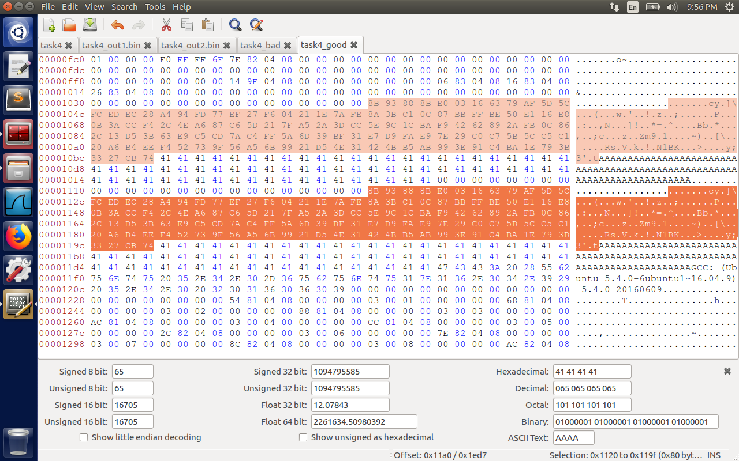

Modification of task4_bad file:

Before modification:

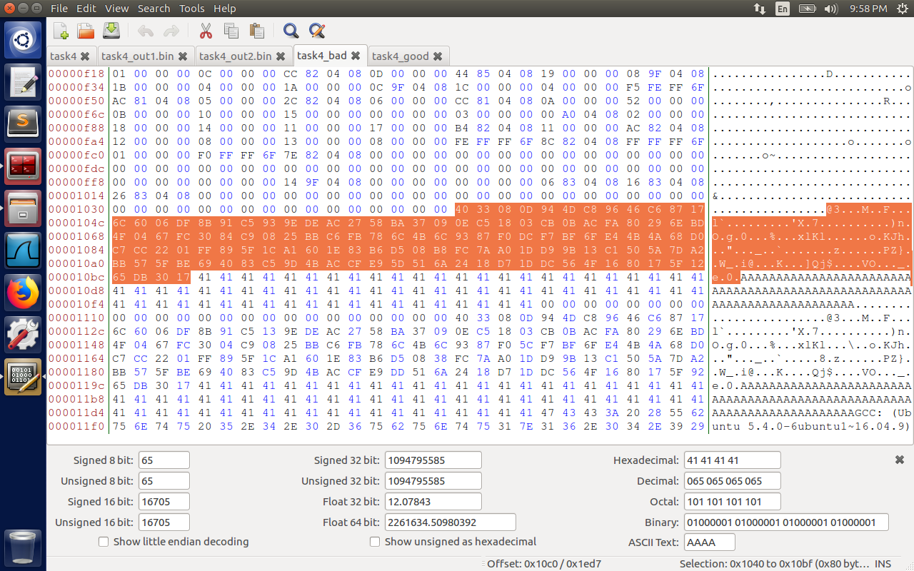

After modifying the content of initial 128 bytes after prefix with q(last 128 bytes of task4_out2.bin)   
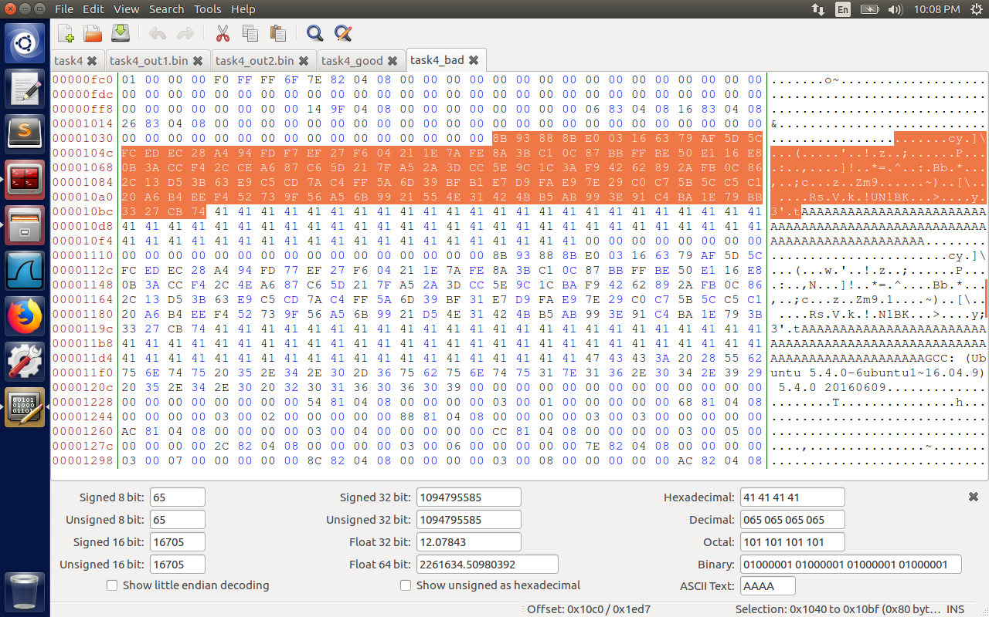

Modify the content of array Y with p (last 128 bytes from task4_out1.bin).  
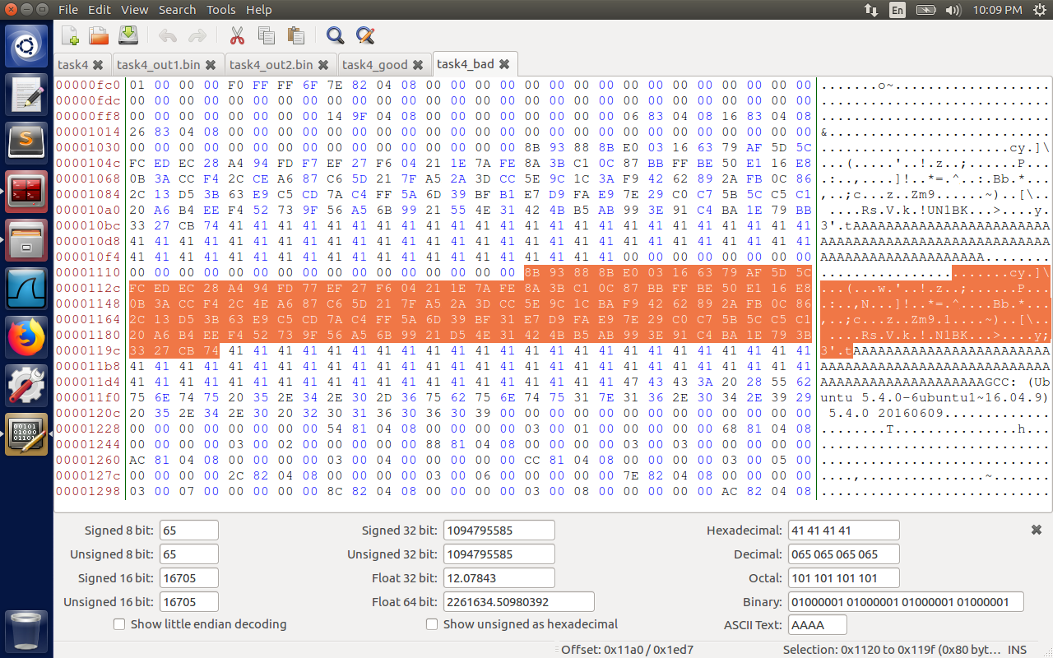

Now observe the outputs below. Task4_good prints the “benign code executed” statement, task4_bad statement executes the “malicious code executed” statement, but the checksum of both the files calculated using md5sum is the same.

